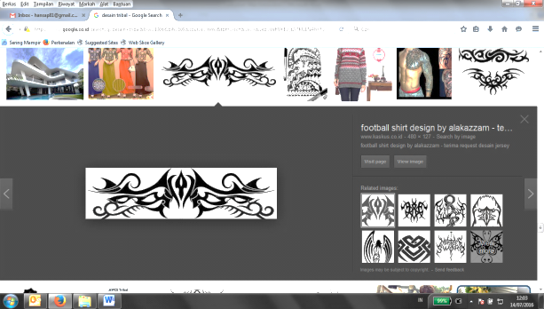**Curiculum Vitae**

Name : Hansa Prasetya

Date of Birth : Yogyakarta 06 Februari 1981

Address : Jl.Wahid Hasyim no.9 Pringgolayan,

Condong Catur, Kab Sleman, Yogyakarta 55283

Marital Status : Married

Telephone Number : (0274) 4333 127

Mobile Phone : 0817 0426 555 / 0878 1222 0999

Driving Licences : A & C

Email : hansap81@gmail.com

# Education

* Graduated from Atma Jaya Yogyakarta University, Faculty of Industrial Engineering S-1 on 2005

**Working Experience**

* Area Sales Operations Coordinator Solo Raya PT KUDO Teknologi Indonesia Sept 2016 - Now
* Regional Promotion Greater Semarang PT XL Axiata, Tbk May 2015 – August 2016
* Regional Promotion Kalimantan 1 (Kalimantan Tengah & Kalimantan Selatan) PT XL Axiata, Tbk January 2015 - April 2015
* Regional Promotion Kalimantan 2 (Kalimantan Timur & Kalimantan Barat) PT XL Axiata, Tbk August 2011 - Des 2014
* Consumer Marketing Representative PT Surya Mustika Nusantara May 2009 - July 2011
* Marketing Manager GM Production March 2007 - April 2009
* Team Leader Direct Sales Mitra Xplor PT Excelcomindo Pratama November 2006 - February 2007
* Promotion Officer PT Bentoel Prima February 2006 - September 2006
* Field Researcher & Marketing Lembaga Survey Indonesia (LSI) Jawa Tengah – Daerah Istimewa Yogyakarta August 2003 - January 2006

**Achievement**

* The Best Growth in GMV (Sales & Online) 210% and Process 170% (Okt 2016/ 1st Month at Kudo)
* Winner Hunger League 2016 (Best Growth KPI Sales & Proses) PT Kudo Teknologi Indonesia
* Winner Sands Project Axis Go To School 2016 (Most Achieved Revenue and Most schools winners)
* Project Hybrid Marketing 2016 (Collaboration merchant with mobile platform XL Diskon)
* Project 360 Degree Q1 2015 in districts Banjar & Martapura produce growth revenue 10,38%
* 3rd Winner The Best Regional Promotion 2014 (National Dex Racing 2014) & 2nd Winner The Best Regional Promotion 2013 (National Dex Racing 2013)
* Growth revenue Kalimantan Timur & Kalimantan Barat 2013 : 13% & Growth revenue Kalimantan Timur & Kalimantan Barat 2014 : 9,5%
* 2nd Winner competition marketing strategy at Millis Marketing Club (Marketing Mix Magazine) on May 2009 titled ”Lee Cooper – Make Your Own Jeans”